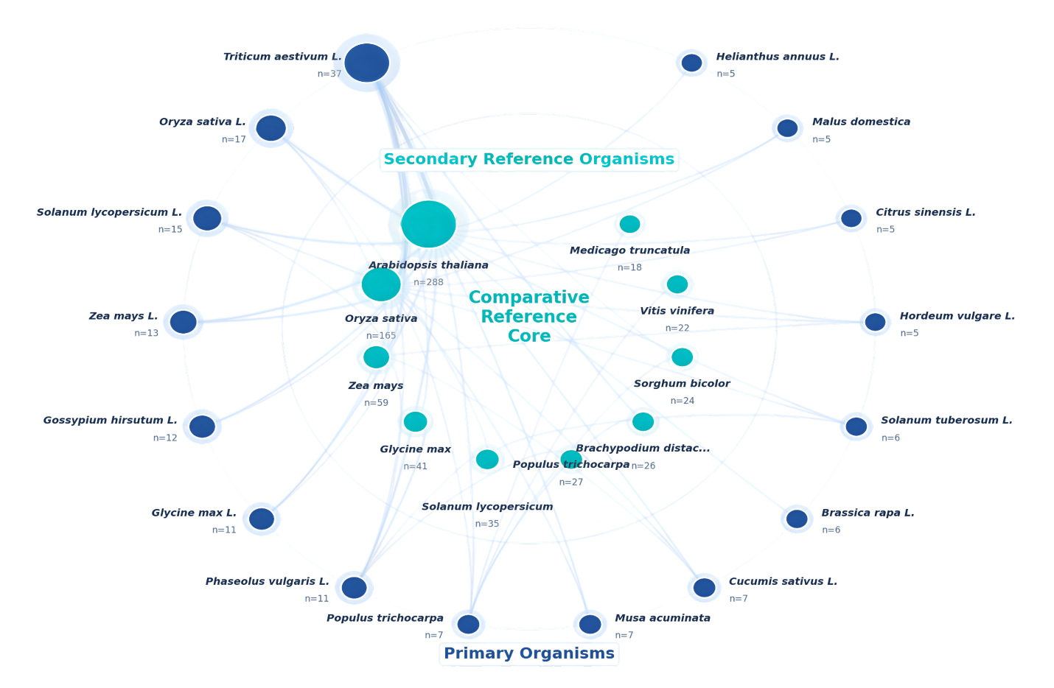
Figure 6. Comparative network of primary and secondary organisms. Network plot representing the relative relationships between the key study organisms (outer blue nodes) and the reference organisms (inner green nodes). The size of the node implies the frequency (n) of the studies, and link density indicates the repeated comparative pairing across studies.

